Samar Essam

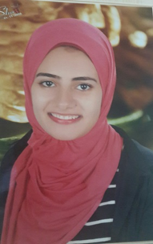

Personal information:

**date of birth: 12/3/1996.**

**Gender: female**

**Marital status : single**

**Phone : 01098697811**

**Email :** [**samaressam1122@gmail.com**](mailto:samaressam1122@gmail.com)

**Linked in account :** [**https://www.linkedin.com/in/samar-essam-63891411a/**](https://www.linkedin.com/in/samar-essam-63891411a/)

**Facebook account:** **https://www.facebook.com/profile.php?id=100006085574083**

**From: aga- eldkhlia Nationality: egyptation**

Education:

faculty of engineering assiut university

3nd mechanical (mechatronics) department.

Skills:

Language : fluent in Arabic and English

Computer knowledge: solidworks ,c++,Msoffice,fortran programing.

Training and courses:

* microcontroller level 1 course
* training at orascom.
* training for 3 days at eg robtics in zweil city to learn how to make an rov.

Other information :

* I am a member in assiut robotics team.
* Participate in IRC completion.
* Make CNC project with assuit robotics team.
* Participate in ELSA competition work on fire fighting project.